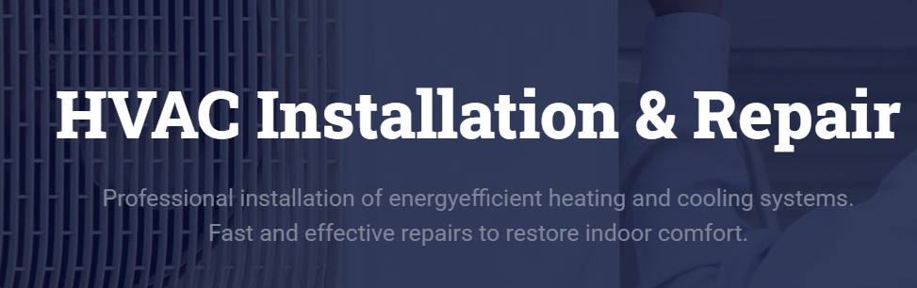
energy efficient

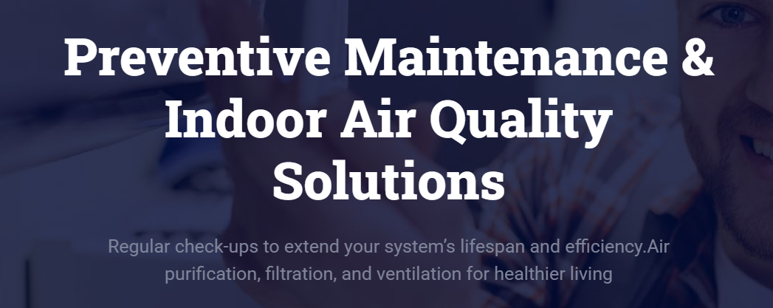
Add a full stop after living. ( looks incomplete sentence)

In our services, Let the first sliding page be
HVAC products supply, installation & contracting.

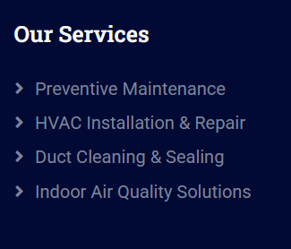 Please add below over here
HVAC Contracting
VRV / VRF Systems
Ductable, Split, and Cassette AC Units
Chilled Water Systems (AHUs, FCUs, Chillers)
Kitchen & Toilet Ventilation Systems
Modular OT
Annual Maintenance Contracts (AMC)
Fresh Air & Exhaust Fans
Packaged Air Conditioning System

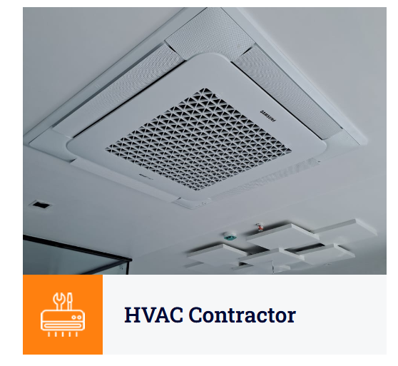This can be removed.
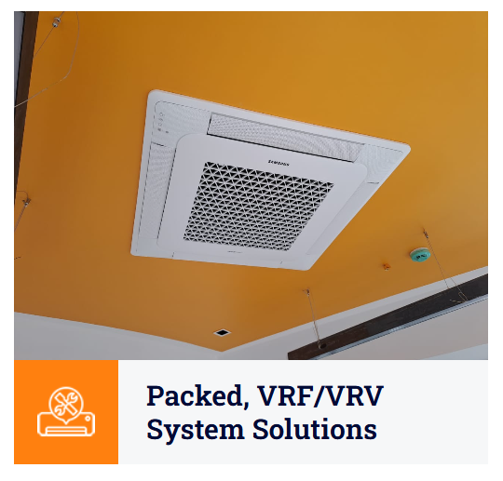This needs to be changed as packaged & vrf/vrv are different systems.

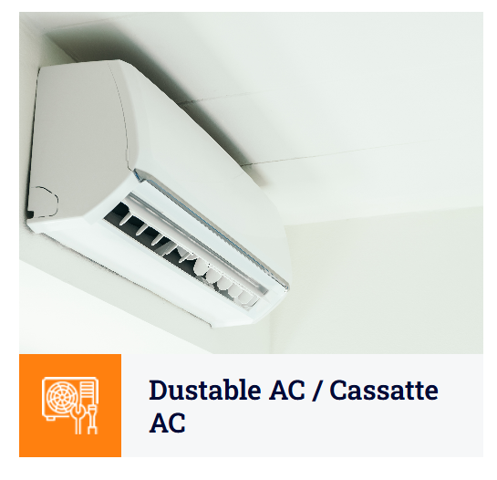Use this photo for Split Air Conditioning. And Ductable AC & Cassette AC are two different types.

For cassette AC use the below
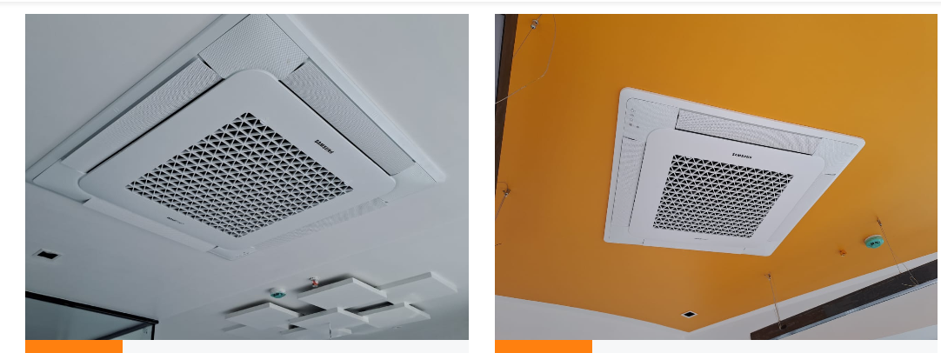

For Ductable use the below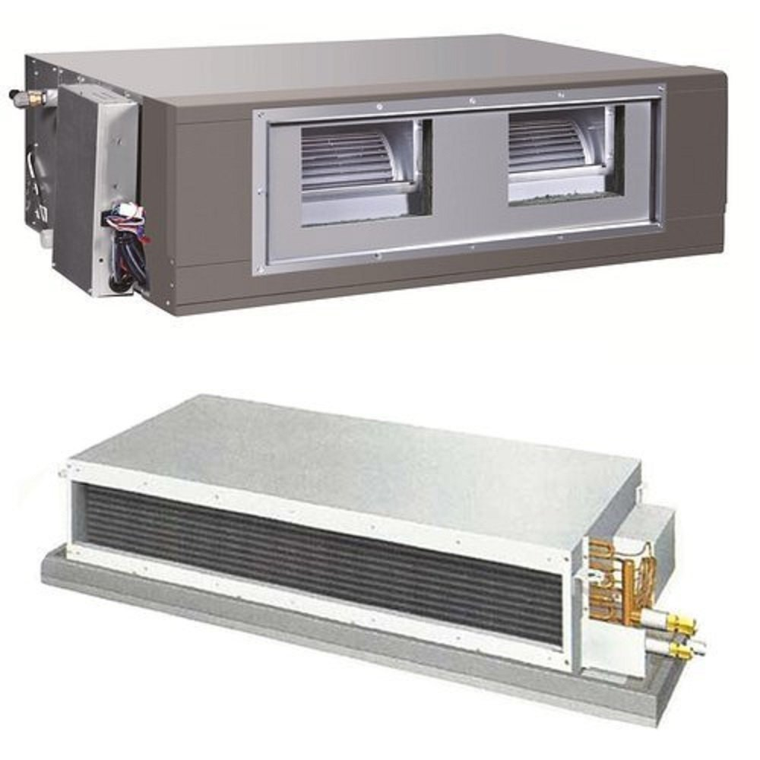
At the below image for Centralized VRF/VRV system
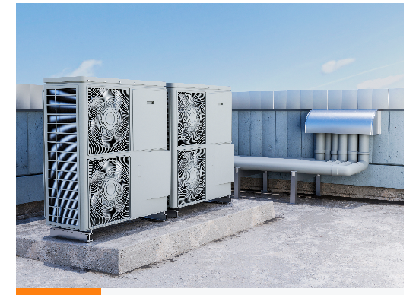
Photos for Basement, Staircase & Cold water system & AHU need to be changed.
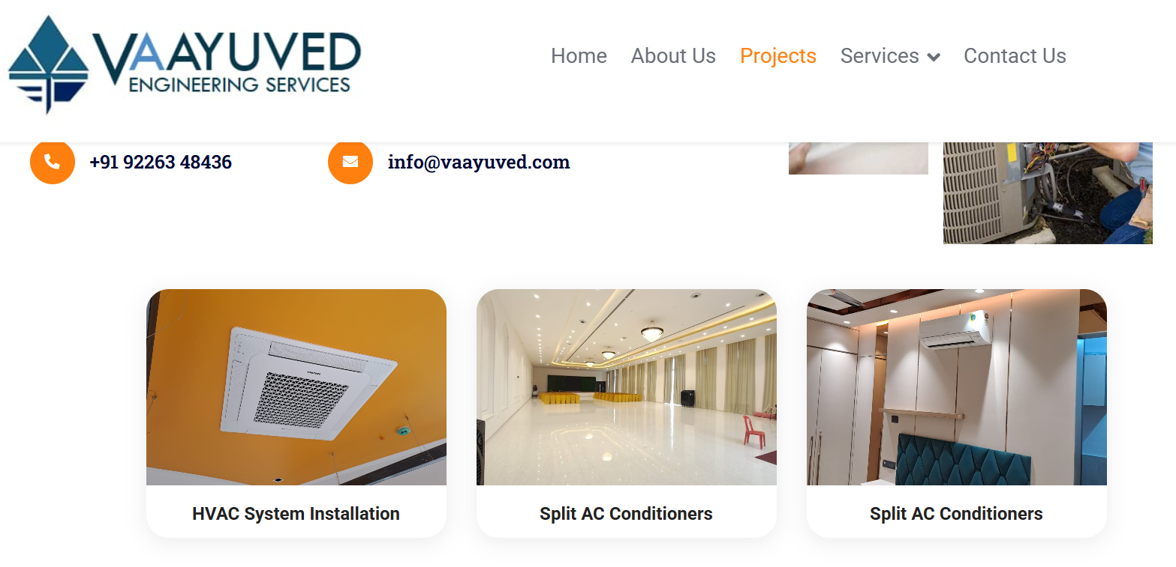

VRF/VRV Supply & Installation DX Ductable unit AMC

Add below points with images.
HVAC Contracting
Comprehensive design, installation, and commissioning of heating, ventilation, and air conditioning systems tailored to residential, commercial, and industrial needs.
VRV / VRF Systems
Advanced variable refrigerant systems offering high energy efficiency, zoning flexibility, and superior comfort control for modern buildings.
Ductable, Split, and Cassette AC Units
Customized air conditioning solutions for diverse spaces—ensuring quiet operation, optimal cooling, and seamless aesthetics.
Chilled Water Systems (AHUs, FCUs, Chillers)
Centralized cooling solutions designed for large-scale facilities, providing precise temperature control and energy savings.
Kitchen & Toilet Ventilation Systems
Effective ventilation designs that ensure odor control, humidity reduction, and improved indoor air quality.
Modular OT (Operation Theatres)
Specialized HVAC systems for healthcare environments, maintaining sterile conditions through precise air filtration and pressure control.
Annual Maintenance Contracts (AMC)
End-to-end preventive maintenance and on-call support to ensure optimal performance and extended lifespan of HVAC systems.
Fresh Air & Exhaust Fans
Efficient air circulation systems to maintain indoor air quality, remove contaminants, and provide a comfortable environment.
Packaged Air Conditioning System
Compact, high-capacity cooling systems ideal for commercial buildings requiring centralized and cost-effective temperature control.

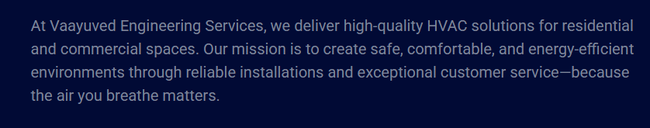
Replace above with
Vaayu se Vedanta, Comfort se Jeevan
We bring comfort to life through reliable HVAC solutions designed for healthier, cleaner, and energy-efficient spaces like homes, offices, and industries. Our goal is to deliver perfect air quality through engineered HVAC solutions, precise installation, and reliable service. — because the air you breathe defines your comfort.

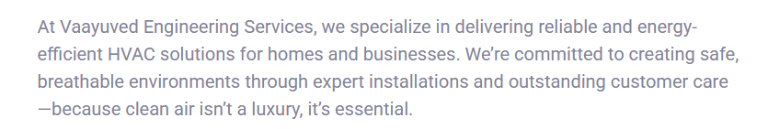
Replace above with
At Vaayuved Engineering Services, we are dedicated to creating spaces that are comfortable, safe and breathable. As an emerging HVAC service provider, our mission is to deliver top-quality air conditioning, heating, and ventilation solutions to both residential and commercial clients. We believe that the air you breathe directly impacts your health and comfort, which is why we prioritize energy-efficient systems, reliable installations, and exceptional customer service. -because clean air isn’t a luxury, it’s essential.

